Simplifying Enterprise Authentication with Kerberos in IBM Db2 Genius Hub

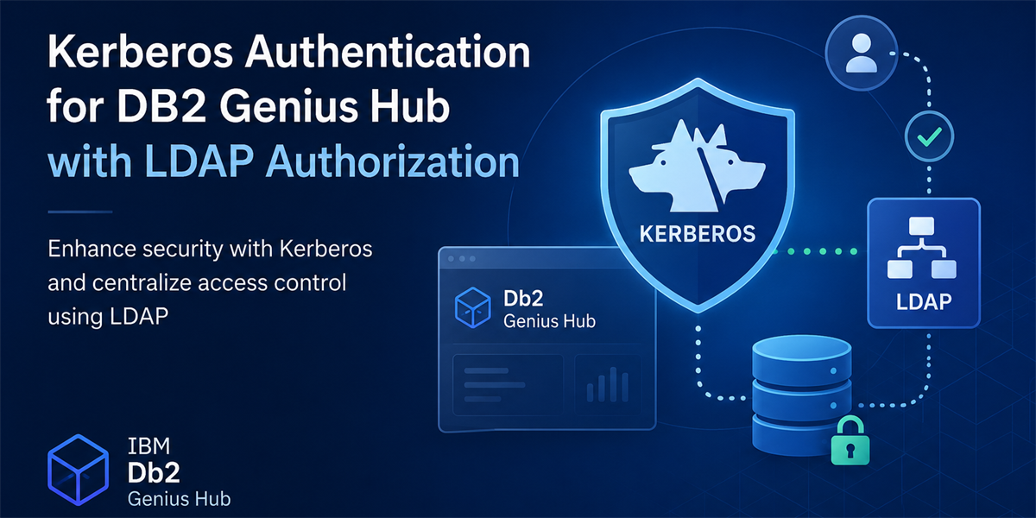

Enterprise applications are expected to integrate seamlessly with an organisation's existing identity infrastructure. Maintaining separate application users and passwords not only increases administrative overhead but also introduces additional security risks.
Most enterprises already rely on centralised authentication systems such as Active Directory or LDAP (Light-weight Directory Access Protocol) backed by Kerberos. Users authenticate once using their enterprise credentials and securely access multiple applications without managing separate passwords.
IBM Db2 Genius Hub now extends this experience by introducing Kerberos Authentication, allowing organisations to leverage their existing authentication infrastructure while maintaining centralised authorisation through LDAP.

Why Kerberos?
Managing application users locally works for small deployments, but it quickly becomes difficult in enterprise environments.
Administrators often needs to:
- Provide Single Sign-On (SSO) for users
- Centralise identity management
- Integrate with Active Directory or OpenLDAP
- Manage permissions using existing LDAP groups
- Eliminate the need to maintain separate application credentials
Rather than introducing another identity store, Db2 Genius Hub integrates directly with your existing Kerberos and LDAP infrastructure, allowing authentication and authorisation to remain under enterprise control.

How Kerberos Authentication Works?
The authentication process combines two enterprise technologies that work together.
- Kerberos verifies the identity of the user through the organisation's Key Distribution Center (KDC).
- Once authentication succeeds, LDAP retrieves the user's directory information and determines which groups the user belongs to.
Db2 Genius Hub then maps those LDAP groups to application roles such as:
- Console Administrator
- Database Administrator
- Database User
This approach keeps authentication and authorisation separate while allowing organisations to continue using their existing directory structure.

Guided Configuration in Db2 Genius Hub
Kerberos configuration is available from:
Administration → Authentication → Kerberos
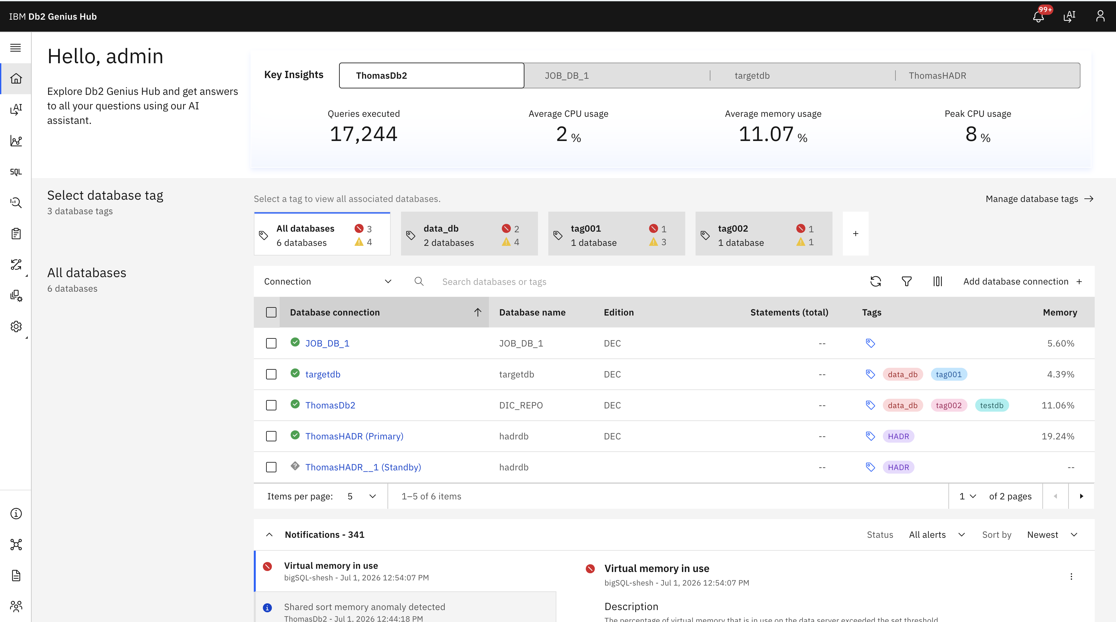

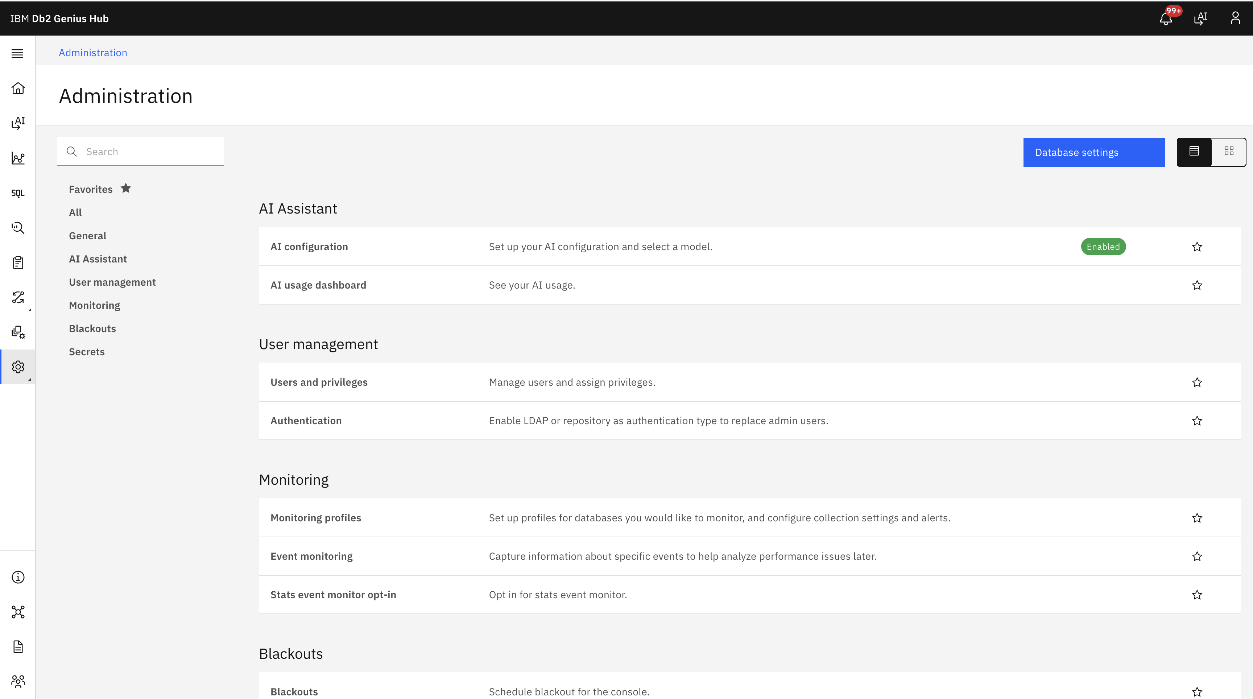
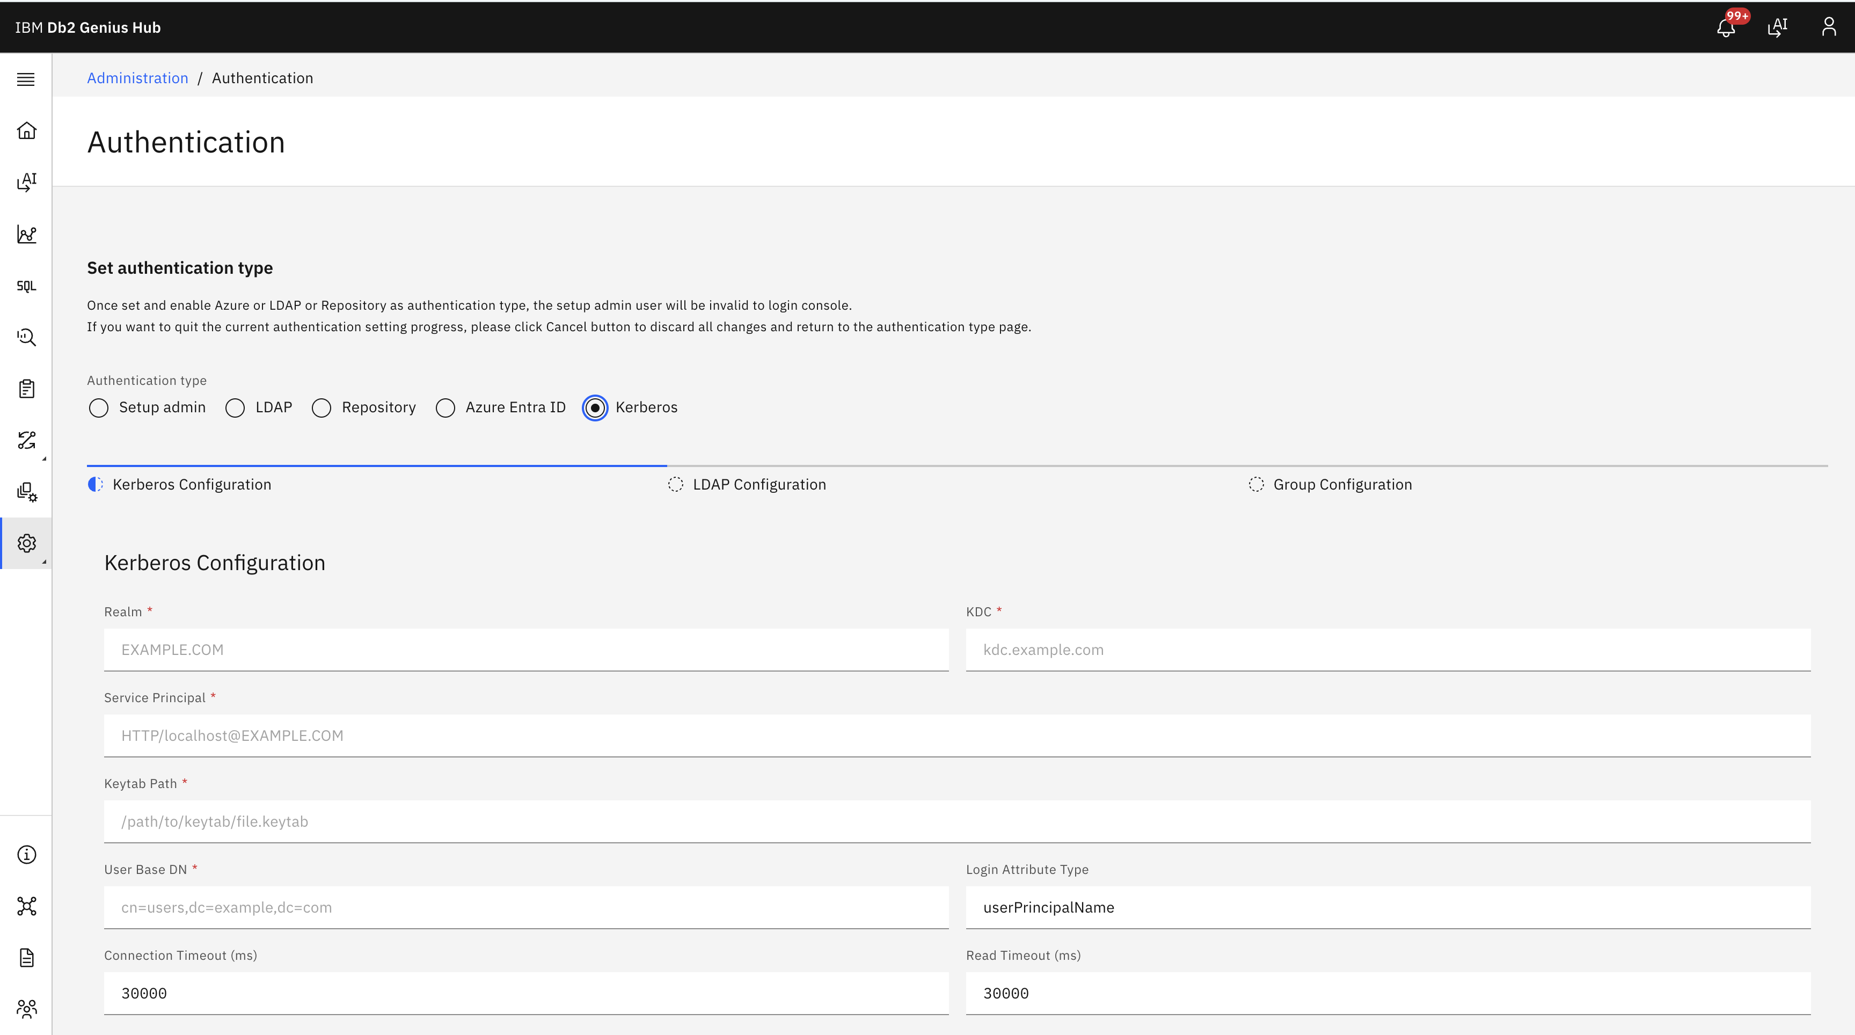
Instead of presenting every setting on a single page, the configuration is organized into a guided three-step workflow that validates each stage before moving forward.

Pre-requisite: Before you start configuring Db2 Genius Hub
- Kerberos configuration and setup up and running
- LDAP Service
- All access and privileges in place

Step 1 – Configure Kerberos
The first step captures the core Kerberos settings required for authentication.
These include:
- Kerberos Realm
- Key Distribution Center (KDC)
- Service Principal
- Keytab file location
- LDAP User Base DN (Domain Name)
Optional settings such as login attributes and timeout values provide additional flexibility for different enterprise environments.
One important requirement is that the configured Service Principal must match the principal stored inside the keytab file. Since Kerberos is case-sensitive, ensuring these values match exactly helps avoid authentication failures.
Also, the Service principal name for IBM Db2 Genius Hub should be of below format.
HTTP/<Genius Hub Hostname>@<REALM>
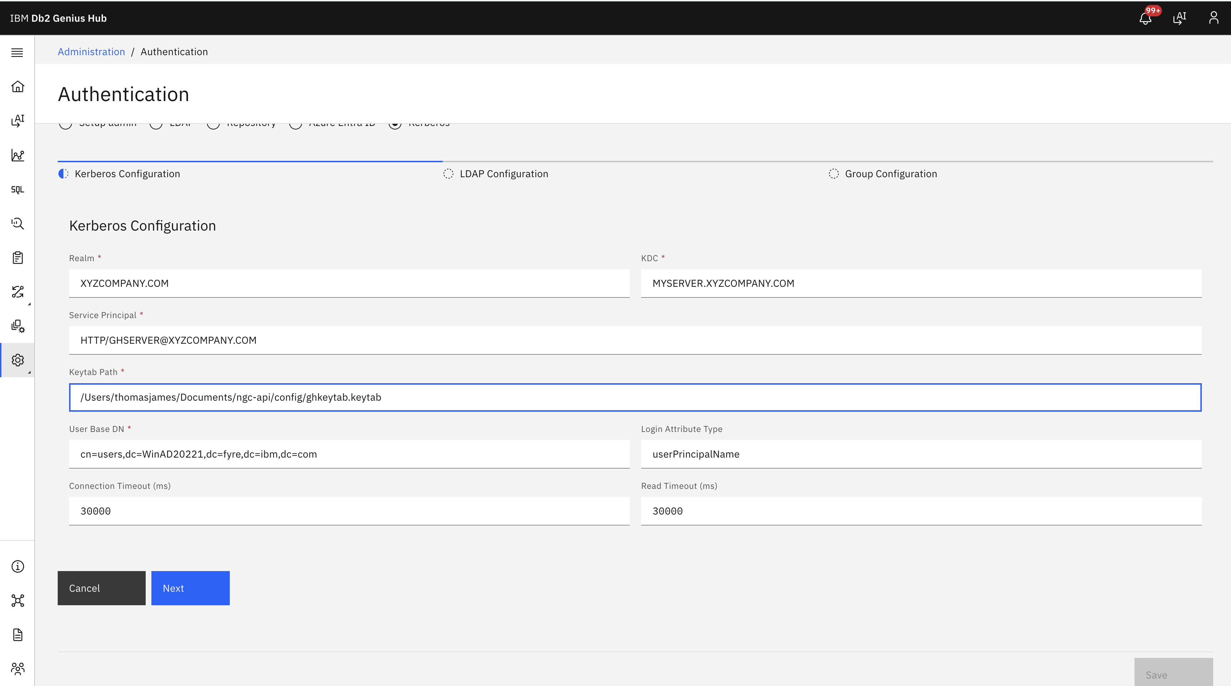
Step 2 – Connect to LDAP
After configuring Kerberos, the next step establishes communication with the organisation's LDAP directory.
Administrators simply provide:
- LDAP server
- Port
- Bind DN
- Bind password
Instead of waiting until the configuration is complete, Db2 Genius Hub immediately validates the LDAP connection before allowing the administrator to continue.
This helps identify common configuration issues such as incorrect server details, invalid credentials, or network connectivity problems early in the setup process.
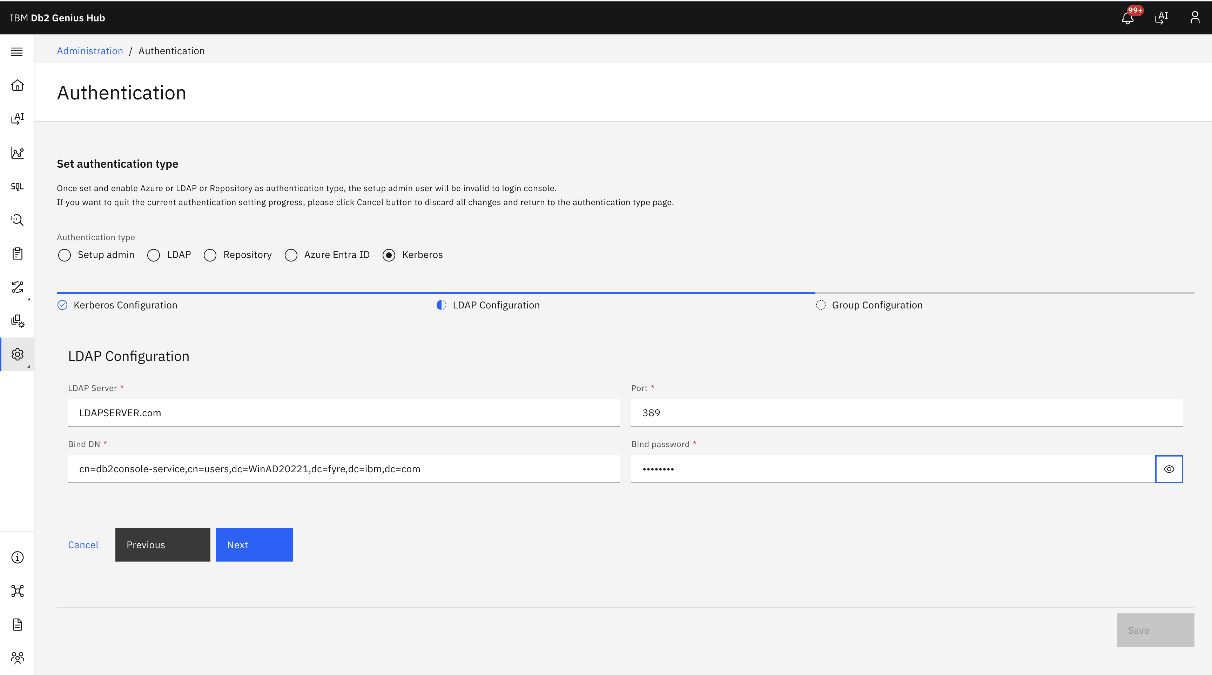
Step 3 – Configure Group Mapping
Authentication alone is only part of the process. Users also need the appropriate permissions inside Db2 Genius Hub.
The final step maps LDAP groups to application roles.
Organisations can associate one or multiple LDAP groups with each role:
Console Administrator
Database Administrator
Database User
Because different directory services represent group membership differently, the configuration also allows administrators to specify the appropriate Member Attribute and User ID Attribute for their LDAP implementation.
Whether you're using Active Directory or OpenLDAP, Db2 Genius Hub provides the flexibility to adapt to your existing directory schema.
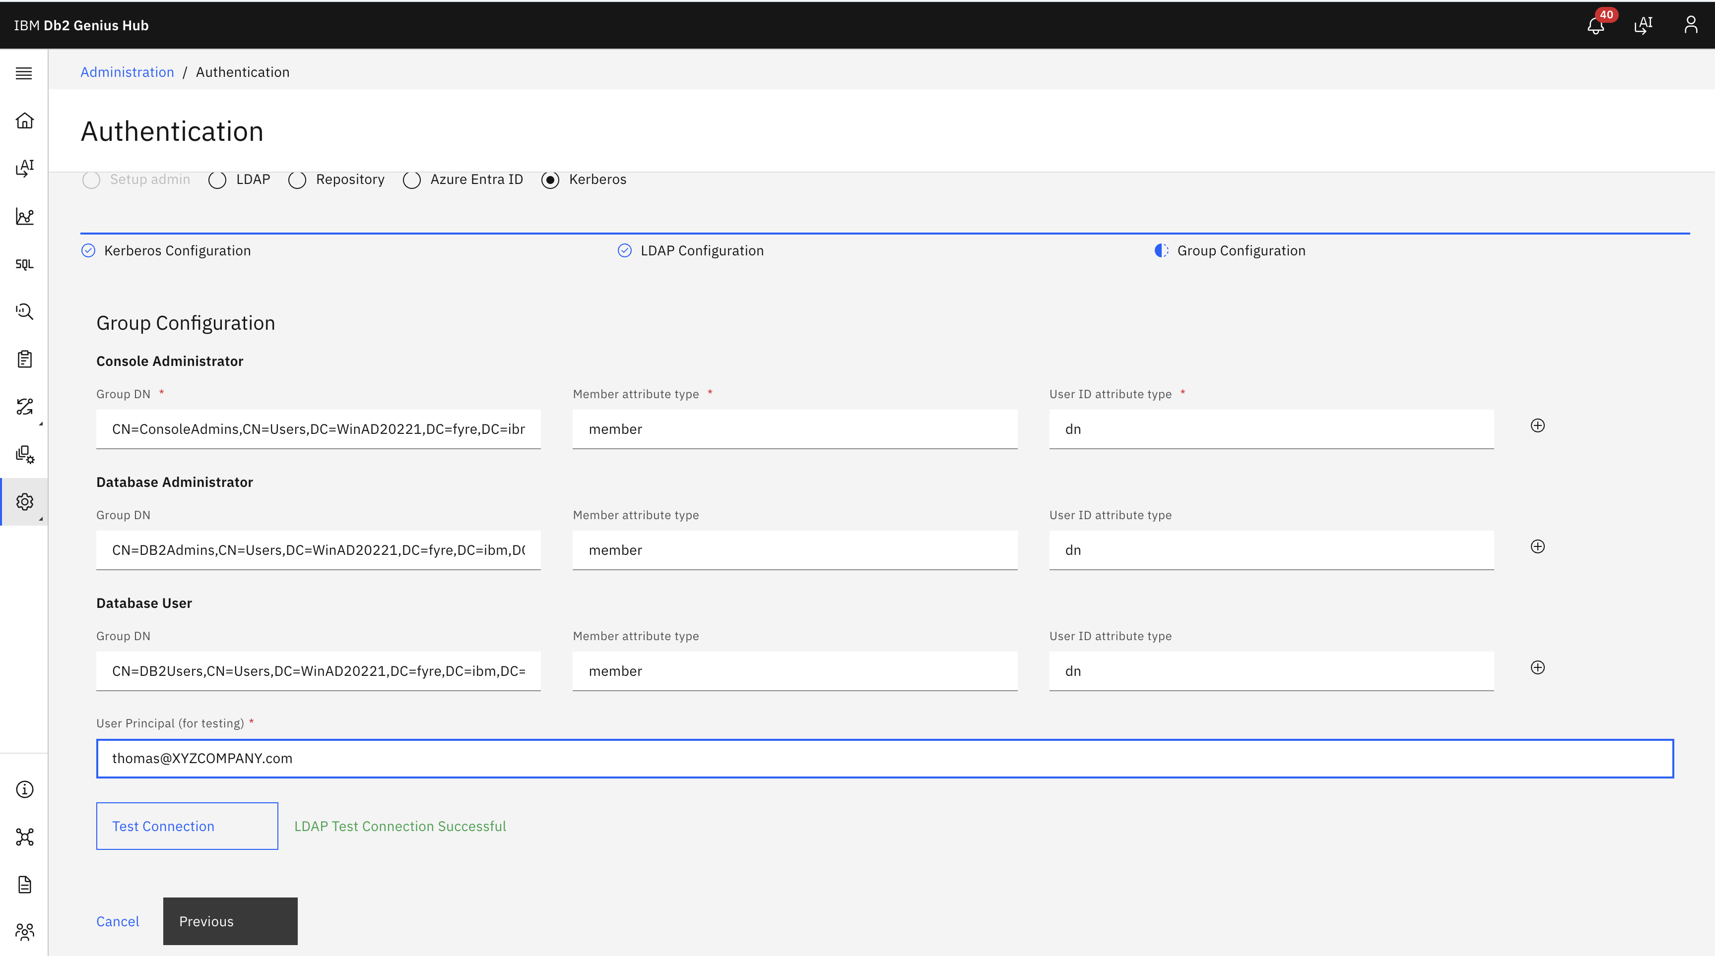
Built-In Validation Before You Save
One of the goals while designing this feature was to minimise configuration errors before Kerberos authentication is enabled.
Db2 Genius Hub performs validation throughout the setup process.

LDAP Connection Validation
When the LDAP configuration is completed, the application automatically verifies:
- LDAP server connectivity
- Bind credentials
- Directory accessibility
Only after a successful validation can administrators proceed to the next step.

User Authentication Validation
Before the configuration can be saved, administrators perform a test using a real Kerberos user principal.
This verifies that:
- Kerberos authentication succeeds
- the user exists in LDAP
- group membership is resolved correctly
- the appropriate application role can be assigned
The Save button becomes available only after a successful authentication test, reducing the risk of deploying an invalid configuration.
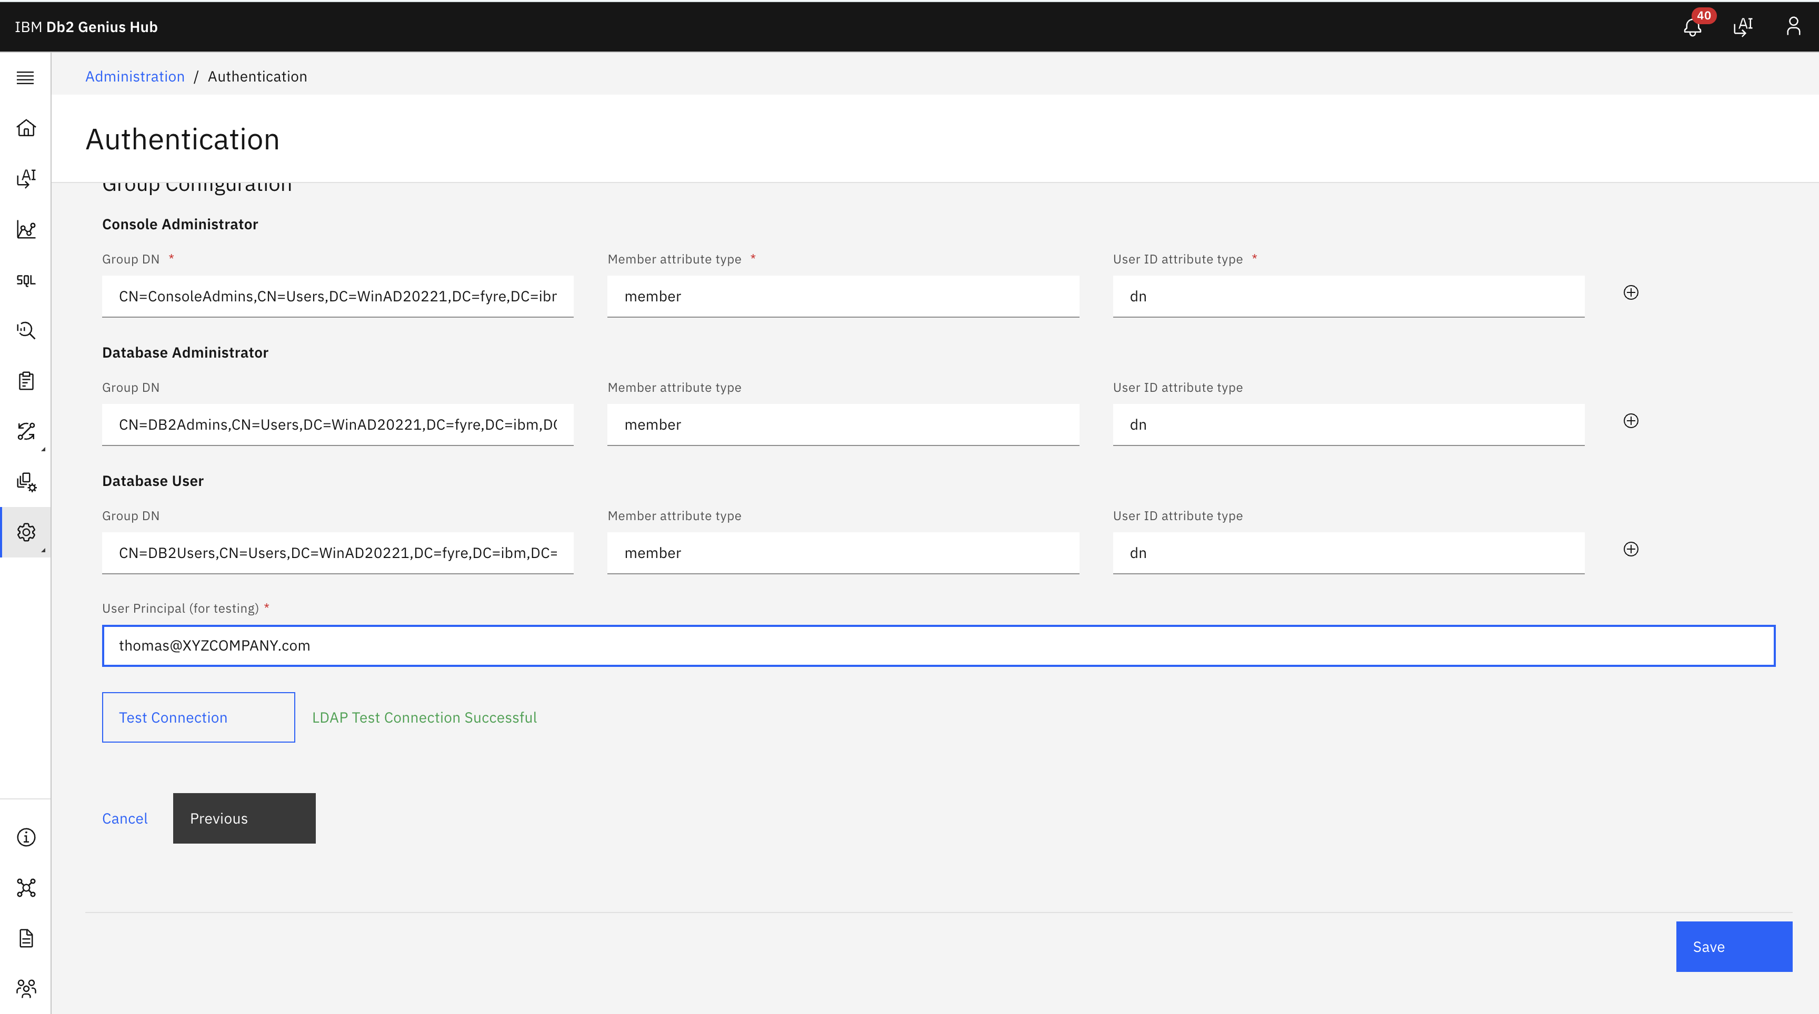
Important Things to Know
Enabling Kerberos changes how users authenticate to Db2 Genius Hub.
Before saving the configuration, administrators should be aware of a few important behaviours:
The initial setup administrator account will no longer be available for console login.
Existing users must sign in again using their Kerberos credentials.
At least one Console Admin LDAP group must be configured before Kerberos can be enabled.
These safeguards help ensure that administrative access is preserved after the authentication provider is switched.
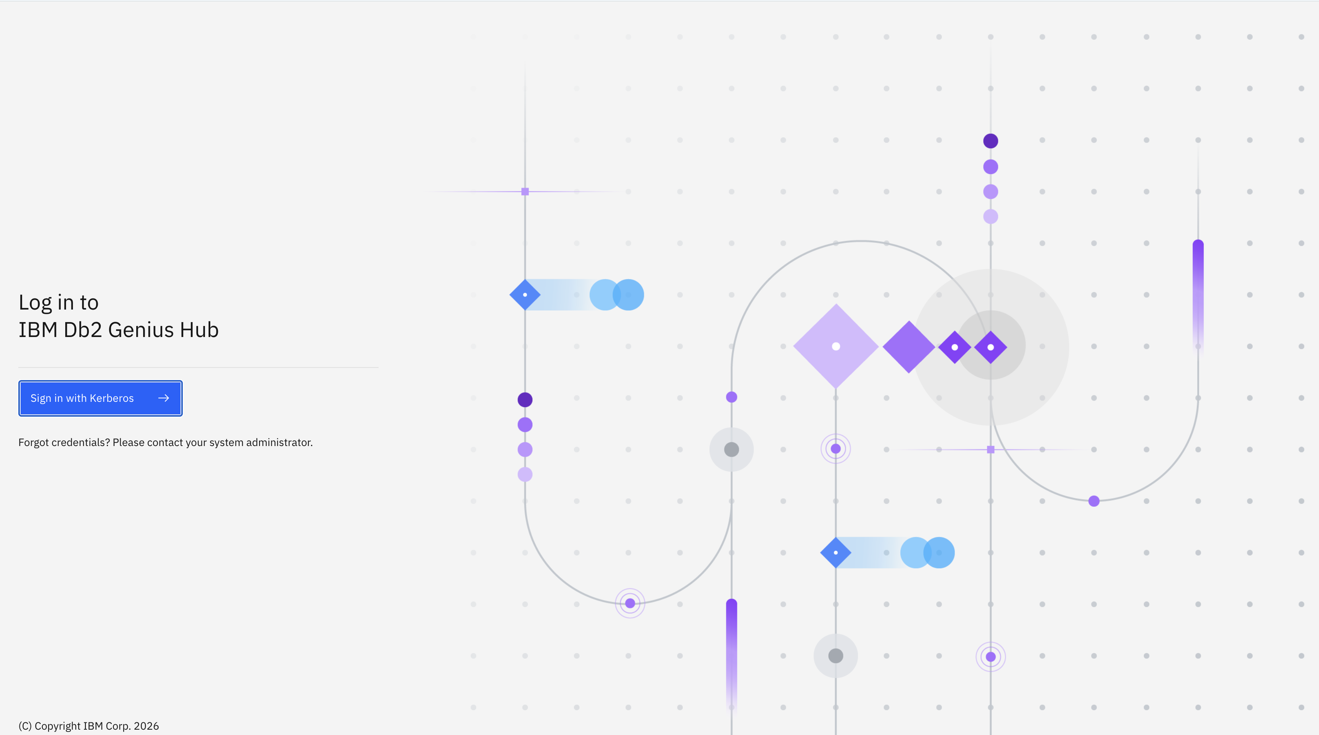
Enterprise Flexibility
The implementation has been designed to support common enterprise identity environments, including:
- Active Directory
- OpenLDAP
- MIT Kerberos
- Other LDAP-compliant directory services
Because attribute mappings are configurable, organisations can integrate Db2 Genius Hub without restructuring their existing LDAP hierarchy.

Benefits
By introducing Kerberos Authentication, IBM Db2 Genius Hub enables organisations to:
- Integrate seamlessly with enterprise Single Sign-On (SSO)
- Eliminate local application credential management
- Leverage existing LDAP groups for authorisation
- Support flexible directory schemas through configurable attribute mapping
- Detect configuration issues early with built-in validation
- Improve security while simplifying user administration

Summary
Enterprise authentication should integrate naturally with an organisation's existing identity ecosystem rather than requiring a separate user management process.
With Kerberos Authentication, IBM Db2 Genius Hub makes that integration straightforward through a guided configuration experience, built-in validation, and flexible LDAP group mapping. Organisations can adopt centralised authentication while continuing to manage authorisation using the directory structures they already trust. For more information refer Db2 GH Kerberos documentation page https://www.ibm.com/docs/en/db2-genius-hub/1.1.x?topic=configuration-configuring-kerberos-authentication-db2-genius-hub
About the Authors
Thomas James is a Lead Software Engineer with 15+ years of experience in the IBM Db2 ecosystem, specializing in enterprise database solutions, database administration tools, and secure authentication frameworks. Currently architecting and developing features for Db2 Genius Hub using Java, Spring, RESTful APIs, and microservices, with a focus on building scalable, enterprise-grade solutions that enhance database performance, operational efficiency, and developer productivity.
Sheshnarayan (Shesh) Agrawal is a Senior Technical Staff Member (STSM) at IBM and serves as the Chief Architect for Db2 Genius Hub and Db2 AI tools. With more than two decades of experience in database tools and APIs, he has played a key role in designing innovative enterprise database solutions. Shesh is also an inventor with seven patents, primarily in the areas of database technologies and developer tools.

